Adjacent Acute Angles

Definition
# Source: AI Source: Provided by: [Data Path: Persons Table -> ID Column: 1, Name_En Column: Motasem Essam] -> From: [ChatGPT] on [7/25/2026]
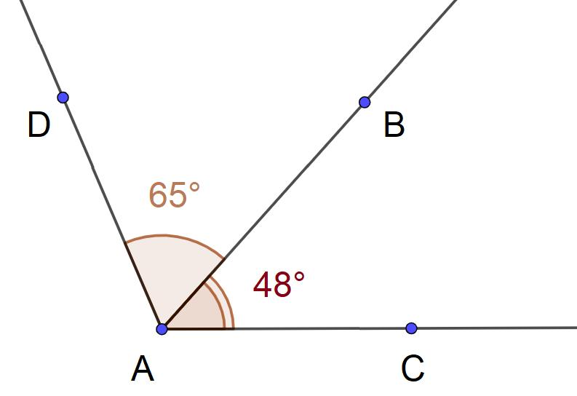
Adjacent Acute Angles are two adjacent angles in which both angles are acute.
An acute angle has a measure greater than $0^{∘}$and less than ${90}^{∘}$:
$$\boxed{0^{∘}<m∠A<{90}^{∘}}$$
Therefore, for two adjacent acute angles $A$and $B$:
$$\boxed{0^{∘}<m∠A<{90}^{∘}}$$
and
$$\boxed{0^{∘}<m∠B<{90}^{∘}}$$

Simple Definition
# Source: AI Source: Provided by: [Data Path: Persons Table -> ID Column: 1, Name_En Column: Motasem Essam] -> From: [ChatGPT] on [7/25/2026]
Adjacent Acute Angles are two angles that share a common vertex and a common side, with both angles measuring less than ${90}^{∘}$.

Conditions
# Source: AI Source: Provided by: [Data Path: Persons Table -> ID Column: 1, Name_En Column: Motasem Essam] -> From: [ChatGPT] on [7/25/2026]
For two angles to be adjacent acute angles, they must satisfy both requirements:
Adjacent
They have:
- the same vertex;
- one common side;
- non-overlapping interiors.
Acute
Each angle must satisfy:
$$0^{∘}<θ<{90}^{∘}.$$
Thus:
$$\boxed{0^{∘}<A<{90}^{∘} \text{and} 0^{∘}<B<{90}^{∘}}$$

Example
# Source: AI Source: Provided by: [Data Path: Persons Table -> ID Column: 1, Name_En Column: Motasem Essam] -> From: [ChatGPT] on [7/25/2026]
Suppose two adjacent angles measure
$$A={30}^{∘}$$
and
$$B={20}^{∘}.$$
Both are acute because
$${30}^{∘}<{90}^{∘}$$
and
$${20}^{∘}<{90}^{∘}.$$
Therefore, they are Adjacent Acute Angles.
Their combined angle is
$$A+B={30}^{∘}+{20}^{∘}={50}^{∘}.$$
So:
$$\boxed{A+B={50}^{∘}}$$
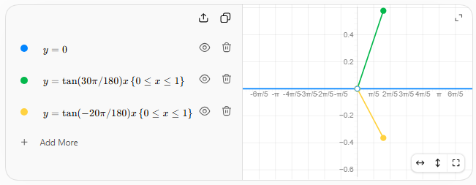

Important Property
# Source: AI Source: Provided by: [Data Path: Persons Table -> ID Column: 1, Name_En Column: Motasem Essam] -> From: [ChatGPT] on [7/25/2026]
The sum of two adjacent acute angles can have different classifications depending on their measures.
For example:
$${30}^{∘}+{20}^{∘}={50}^{∘}$$
The resulting angle is acute.
But:
$${60}^{∘}+{20}^{∘}={80}^{∘}$$
is also acute, while
$${60}^{∘}+{30}^{∘}={90}^{∘}$$
is a right angle.
And:
$${80}^{∘}+{30}^{∘}={110}^{∘}$$
is obtuse.
Therefore:
$$\boxed{\text{Adjacent Acute Angles do not necessarily have an acute sum.}}$$

Relationship with Adjacent Complementary Angles
# Source: AI Source: Provided by: [Data Path: Persons Table -> ID Column: 1, Name_En Column: Motasem Essam] -> From: [ChatGPT] on [7/25/2026]
If two adjacent acute angles satisfy
$$A+B={90}^{∘},$$
then they are also Adjacent Complementary Angles.
For example:
$${45}^{∘}+{45}^{∘}={90}^{∘}.$$
So:
$$\boxed{\text{Adjacent Acute Angles}+\text{Sum }{90}^{∘}=\text{Adjacent Complementary Angles}}$$
However, not every pair of adjacent acute angles is complementary.
For example:
$${30}^{∘}+{20}^{∘}={50}^{∘}.$$
These are adjacent acute angles, but they are not complementary.

Key Points
# Source: AI Source: Provided by: [Data Path: Persons Table -> ID Column: 1, Name_En Column: Motasem Essam] -> From: [ChatGPT] on [7/25/2026]
- Two adjacent acute angles share a common vertex and common side.
- Their interiors do not overlap.
- Each angle measures:
$$\boxed{0^{∘}<θ<{90}^{∘}}$$
- Their sum is not fixed.
- Their sum can be acute, right, or obtuse.
- If their sum is ${90}^{∘}$, they are also adjacent complementary angles.
- They are not necessarily complementary.

Conclusion
# Source: AI Source: Provided by: [Data Path: Persons Table -> ID Column: 1, Name_En Column: Motasem Essam] -> From: [ChatGPT] on [7/25/2026]
Adjacent Acute Angles are adjacent angles where both component angles are acute:
$$\boxed{0^{∘}<A<{90}^{∘}, 0^{∘}<B<{90}^{∘}}$$
For example,
$$\boxed{{30}^{∘}+{20}^{∘}={50}^{∘}}$$
forms a pair of adjacent acute angles.

